**Instructions to execute file/jar**

**Filename:** squareroot.scala

**jarfile:** squareroot_cigna.jar

**Method 1: Command Prompt**

1. Copy the Jar file into desired location on your windows system
2. Open Command Prompt
3. Navigate to the folder in which you have placed the jar file
4. Type in java -jar <jarfilename> <argument>

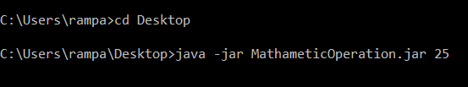

1. You will see the result like below

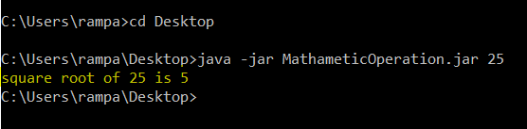

**Method 2: Scala**

1. Move the file from windows to Linux location
2. Give command chmod 777 <filename>
3. Execute the file: scala <filename> <argument>

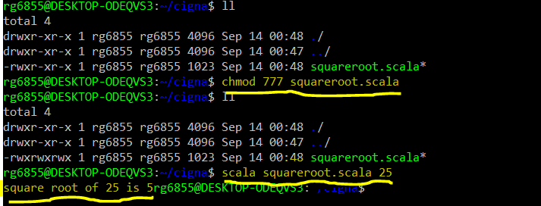

**Method 3: Scala**

1. Place the jar in desired folder
2. Go to the folder
3. Give executable permission with chmod 777 <jar>
4. Execute the jar: scala <jarfile> <argument>

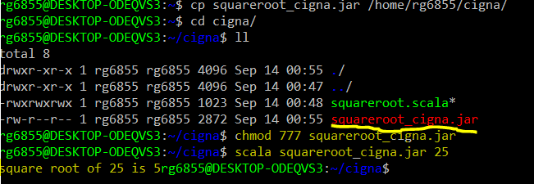

**Method 5: IntelliJ**

1. Import the attached project file
2. Create a jar
3. Run the jar either in windows command prompt or in Linux

